QUERY JOIN, LEFT AND RIGHT

1. [SELECT](http://localhost/phpmyadmin/url.php?url=https://dev.mysql.com/doc/refman/5.5/en/select.html) pelanggan.nama, resep_obat, dokter FROM `resep` JOIN pelanggan ON resep.id_pelanggan = pelanggan.id

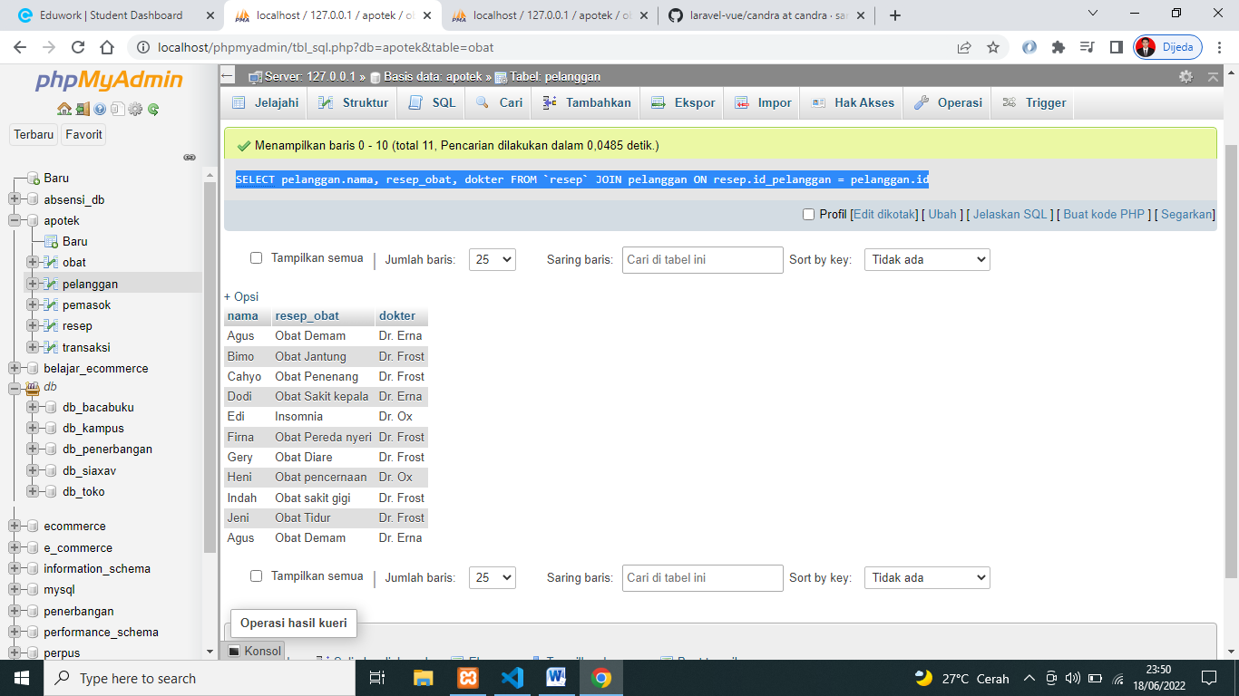

1. [SELECT](http://localhost/phpmyadmin/url.php?url=https://dev.mysql.com/doc/refman/5.5/en/select.html) pelanggan.nama, resep_obat, dokter FROM `resep` JOIN pelanggan ON resep.id_pelanggan = pelanggan.id ORDER BY dokter ASC

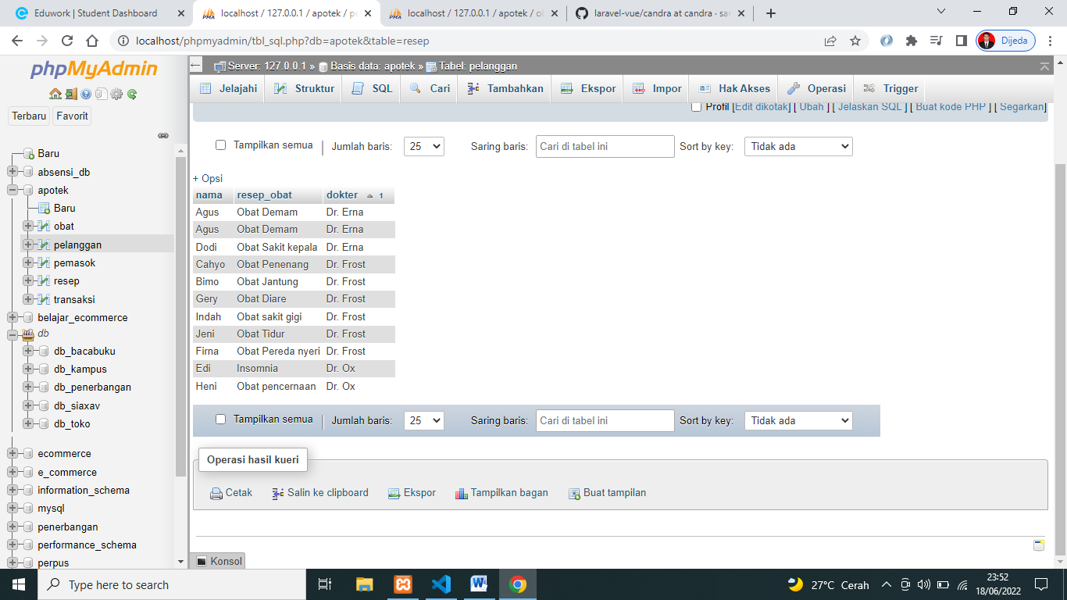

1. [SELECT](http://localhost/phpmyadmin/url.php?url=https://dev.mysql.com/doc/refman/5.5/en/select.html) merk, stok, pemasok.pemasok FROM `obat` [RIGHT](http://localhost/phpmyadmin/url.php?url=https://dev.mysql.com/doc/refman/5.5/en/string-functions.html#function_right) JOIN pemasok ON obat.id_pasokan = pemasok.id  
   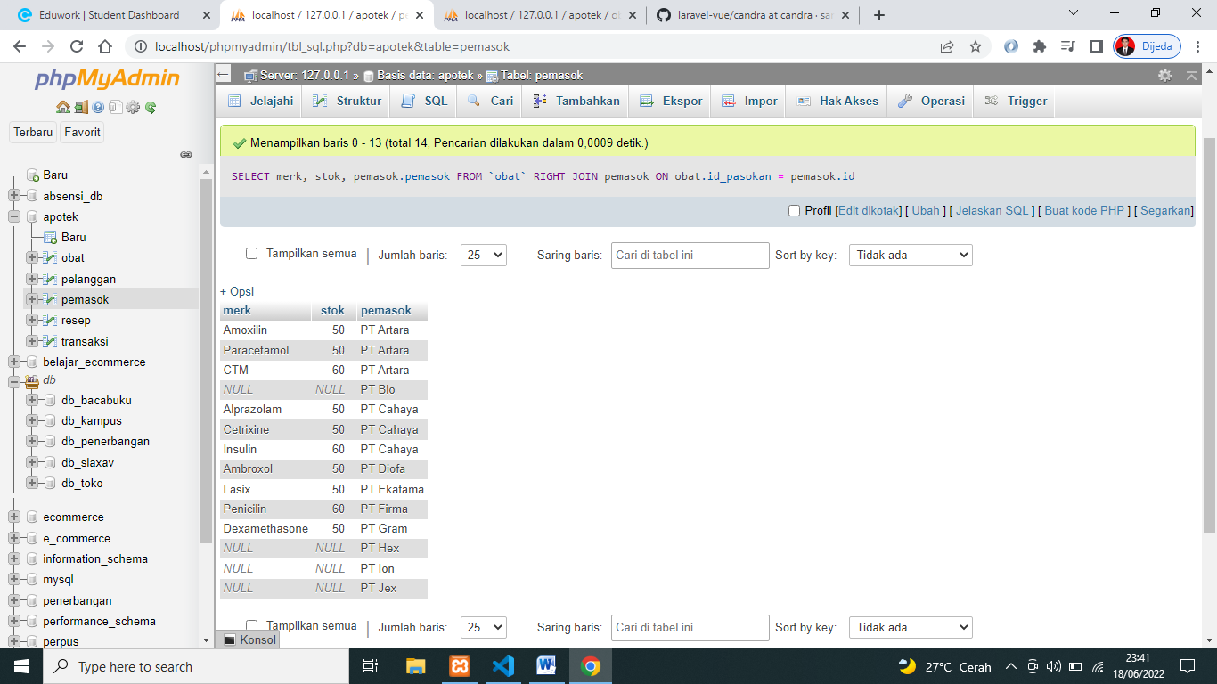
2. [SELECT](http://localhost/phpmyadmin/url.php?url=https://dev.mysql.com/doc/refman/5.5/en/select.html) merk, stok, pemasok.pemasok FROM `obat` [LEFT](http://localhost/phpmyadmin/url.php?url=https://dev.mysql.com/doc/refman/5.5/en/string-functions.html#function_left) JOIN pemasok ON obat.id_pasokan = pemasok.id ORDER BY 'merk' ASC

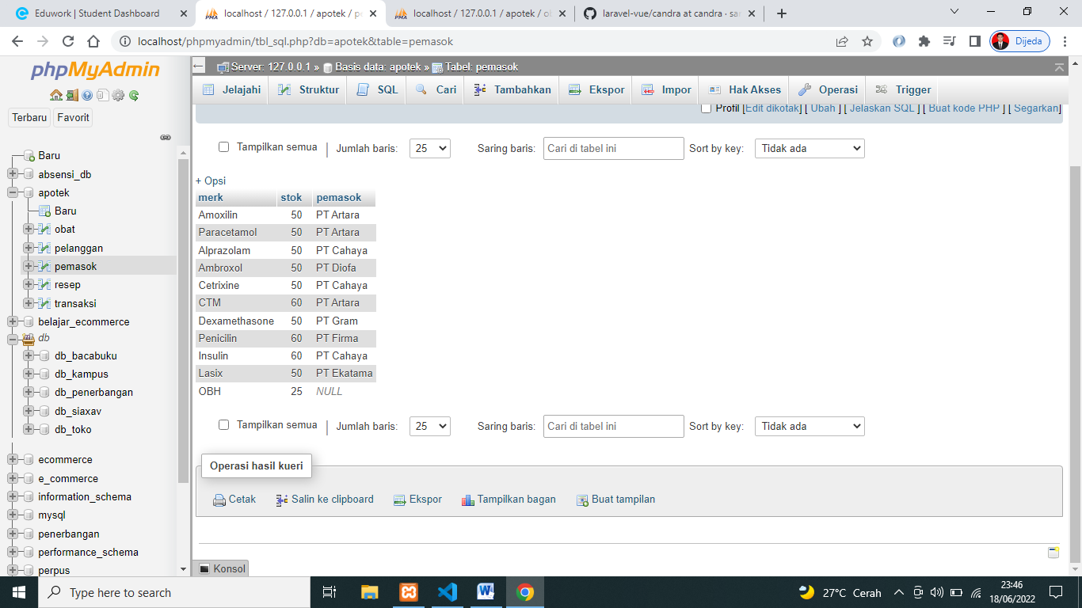

1. [SELECT](http://localhost/phpmyadmin/url.php?url=https://dev.mysql.com/doc/refman/5.5/en/select.html) merk, stok, pemasok.pemasok FROM `obat` JOIN pemasok ON obat.id_pasokan = pemasok.id WHERE merk [LIKE](http://localhost/phpmyadmin/url.php?url=https://dev.mysql.com/doc/refman/5.5/en/string-comparison-functions.html#operator_like) '%lin%' ORDER BY 'merk' ASC

